Send us some information about you and your product.
Email the answers back to info@silverstatefoods.com
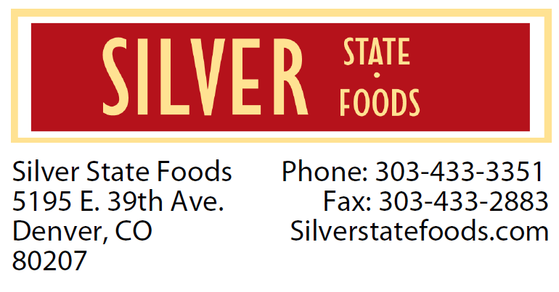
Name:
Phone Number:
Email:
Date:

There can be quite a bit involved in making food products. Let’s start by asking a few questions.
1) What is the product? Pasta sauce, BBQ sauce, Salsa...
2) Does it contain meat?
3) What is the predominant ingredient and some of the other ingredients?
4) Is it chunky or smooth? (compare chunk to a pencil eraser)
5) Cooked?
6) Retail or Food Service?
7) What is the preservation method: shelf stable, refrigerated, or frozen?
8) Do you know the pH and water activity?
9) What type of container? (ie: glass jars, round, square tall, skinny, 16oz, 32oz, gallon jugs, etc...)
10) Will you provide ingredients or would you like for us to provide for you?

11) Do you have a label?
a) UPC?
b) Nutrition Panel?
c) Ingredient Declaration?
12) Is your recipe in pounds or cups?

13) Do you have POs currently? (Selling to anyone)

14) How did you hear about SSF?

15) Have you researched other copackers?

16) Before we go much further, we'll need to have the following forms: Non-Disclosure, Your Sales Tax License and or Business License, Proof of your Liability Insurance, Contract

Notes: SSF is not set up for oven or open flame preparation Minimum production: 5 Gallons (dependent on process and other details) Maximum production: 500 Gallons (2 - 250 gallon kettles)

